Title – Times New Roman, 14 pt, bold, black, centered

Author(s) – Times New Roman, 12 pt, black, centered
Affiliation, City, State/ZIP, Country – Times New Roman, 12 pt, black, centered

Email –Times New Roman, 12 pt, black, centered

- Heading – Times New Roman, 12 pt, bold, numbered, left-aligned
MORIS (Magnetics and Optics Research International Symposium) is the world's leading forum for discussions on fundamental and applied research in the area of magnetic, magneto-optical, and thermo-magnetic phenomena, materials, and devices. It highlights recent trends extending toward ultrafast dynamics, magnetic recording, energy conversion, high-frequency applications, and their interconnections.

- Heading
Instructions:
Digests must be written in English and must follow the guidelines below:
- Limit the digest length to two pages, including figures, tables, results, discussion, and references.
- Fit the entire digest within a 17 cm × 22 cm rectangular area for offset reproduction on A4 paper.
- Save the digest as a PDF (.pdf) file.
- Submit the digest online by 17 January 2026. The submission system will close automatically after the deadline.
- Do not send digests directly to the conference secretariat.

- Heading
- All paragraph text should be set in Times New Roman, 12 pt, black, justified.
- Titles of figures, tables, and photographs should also be in 12 pt font.
- Captions and legends must use 12 pt, with caption labels in bold, e.g., “Fig. 1”.
- The References section title should not include a section number.
- Ensure that your formatting matches the examples provided in this template.

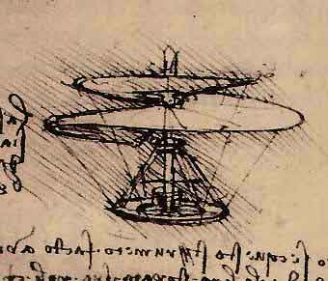

Fig.1 Figure caption: Times New Roman, 12 pt.

- Heading
Please note that all digests will be printed in black and white. Digests will be evaluated based on originality and the significance of the results. Accepted digests will appear in the Technical Digests distributed at the symposium.
Authors of papers accepted for MORIS2026 are encouraged to submit an original and significant portion of their work to the Focus Collection of the Japanese Journal of Applied Physics (JJAP), to be published in 2027. The anticipated submission deadline is July 2026. Authors should follow JJAP’s manuscript preparation guidelines. Please note that manuscripts will undergo JJAP’s standard peer-review process; the special issue is not a proceedings volume of MORIS2026.

References
- Author names, Journal Name, Volume, page (year).
- Author names, Book Title, Editor(s), page (publisher, place of publication, year).

